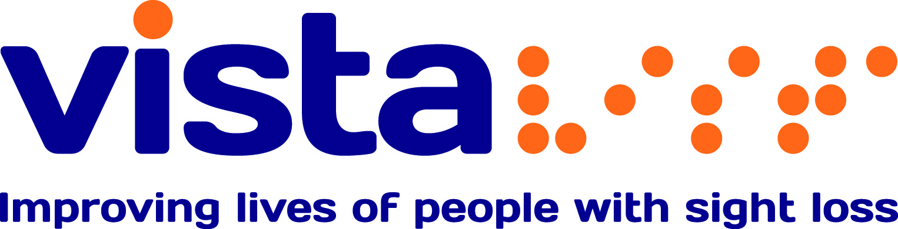

Assessment and
Visual Impairment Rehabilitation
Course Programme

October – December 2014

Cookery courses
Our two day cookery courses provide you with the skills and techniques for you to safely and effectively use kitchen utensils and assistive technology when cooking.
Through these courses, we aim to improve the health and wellbeing of people with sight loss and increase the choice and control of their lives.
There is a charge of £7.50 per day (£15 for a two day course) to cover the cost of ingredients. If you would like to attend a cookery course, please complete the enclosed booking form.
Date | Topic
Monday 29 September and  Monday 6 October  10.30am - 3pm | One Pot Cookery
Monday 1 and Tuesday 2 December  10.30am - 3pm | Christmas Baking
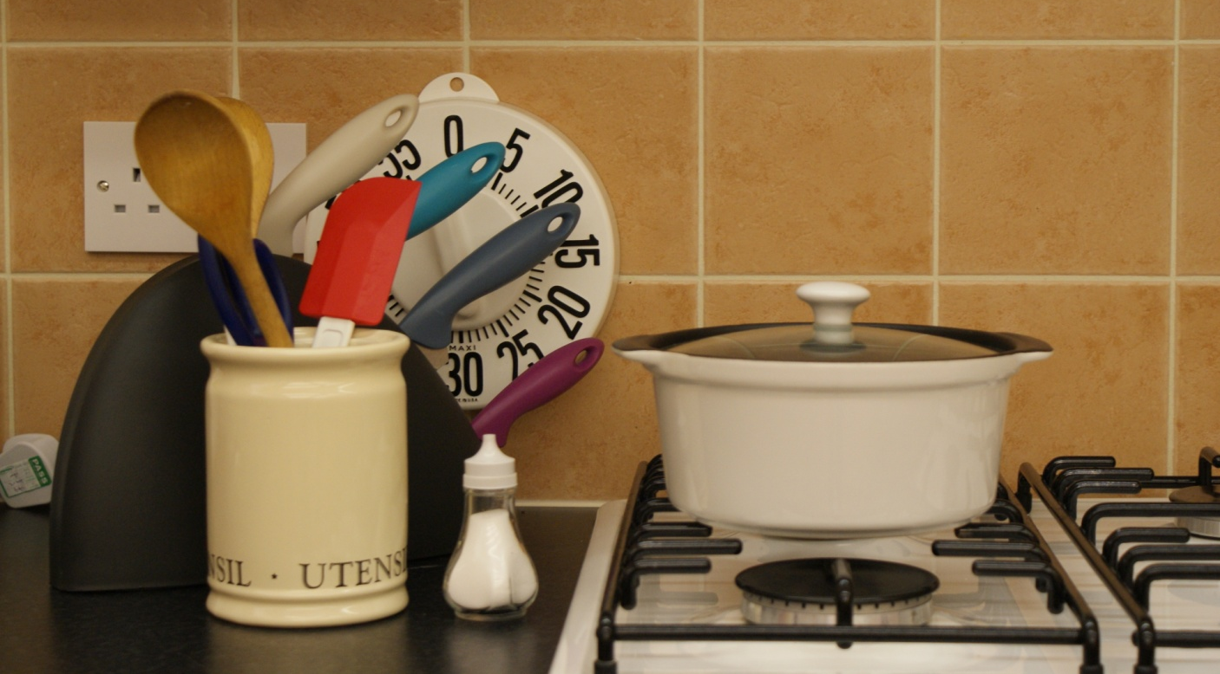

Information Days
Join us for a range of informative talks and presentations on a variety of topics.
Each session provides an opportunity for questions and many feature equipment demonstrations.
All of these information days will be taking place 10:30-1pm in the Vista shop, 21 Hotel Street, Leicester, LE1 5AW. Transport can be provided if you can demonstrate a need.
To book your place or find out more please contact Vista’s Helpline on 0116 249 8839.
Date | Topic
Thursday 2 October | Magnification Information Day (Low Vision Aids)
Thursday 16 October | Benefits Information Day
Thursday 6 November | Mobility Information Day
Thursday 4 December | Guide Dogs Information Day  Please note: This event will be held at Kathleen Rutland Home, 117 Hinckley Road, Leicester Forest East, LE3 3PF

Living with Sight Loss Course
This three day course covers a wide range of topics and provides information and practical advice for living with a sight loss.
Run by our rehabilitation team, the course will:
- Tell you all about Vista and our services
- Let you know what benefits are available to you
- Provide information and practical advice for everyday living
- Update you on communication and technology
- Provide information and practical advice for independent mobility
- Include a day in our teaching kitchen to learn new skills whilst preparing a 2 course meal
Transport can be provided.

Date | Time
Wednesday 29 October to Friday 31 October | 10:30am - 3:00pm
Monday 17 November to Wednesday 19 November | 10:30am - 3:00pm
Monday 15 December to Wednesday 17 December | 10:30am - 3:00pm

Course Booking Form – 2014
Name:
Address:
Telephone number:
Email:
Name and date of the information day I would like to attend:

Cookery course I would like to attend:

I would like to attend the Living with Sight Loss
course:
Please return this form to: Sue Allen c/o Vista’s
rehabilitation team, Vista House, 1A Salisbury Road, Leicester, LE1 7QR.
Spaces are limited and will be allocated on a first come, first served basis. There is a charge for the cookery courses to cover the cost of ingredients. Transport can be provided.

Cancellations must be made as soon as possible by telephoning the Vista Helpline on:
0116 249 8839
If you require the information contained in this programme in an alternative format (e.g. extra large print, Braille or audio) or in an alternative language, please contact our helpline on 0116 249 8839.

Contact us:
Vista
Vista House
1a Salisbury Road
Leicester
LE1 7QR
T: 0116 249 8839
E: info@vistablind.org.uk
W: www.vistablind.org.uk

Charity No: 218992

